 

**INTERNSHIP REPORT**

**Submitted to**

**OTBI, OSMANIA UNIVERSITY**

**Web development project**

**on**

**Water Footprint Calculator**

Sustainable development growth

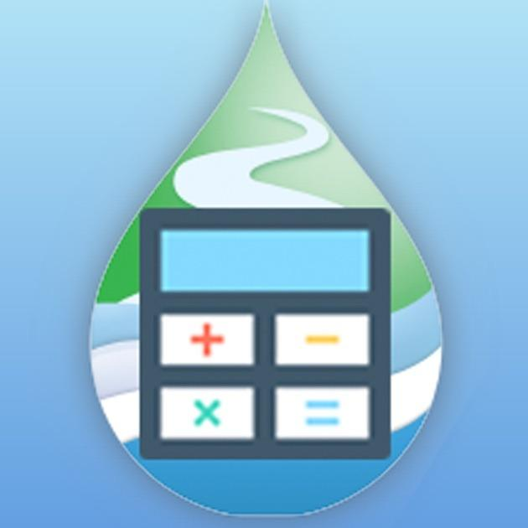

**By**

**Ms. Sumaiya**



24th May, 2024

# Internship Completion Certificate

This is to certify that the following student have successfully completed their internship at our centre from April 2024 to May 2024:

**Ms. Sumaiya**  2nd Year, M.sc (Maths with Computer Science), **University College of Science, Osmania university.**

During this period, Ms. sumaiya worked on the project titled “ **Water footprint calculator** ” at OTBI under the guidance of **Dr. P. Sudheer kumar** **,**CEO,M/s APEX SDG-incubated at OTBI.

She has demonstrated excellent professional skills, dedication, and a strong commitment to their assigned tasks. Her performance has been commendable, and the contributions made during this internship have been significant and valuable to our centre.

This certificate is issued based on the internship report submitted by the group, which reflects the work done and the outcomes achieved during the internship period.

We wish she all the best in her future endeavours.

**Dr. T. Harinarayana**

**(OTBI Advisor) Dr. E. Vidyasagar**

**Director**

(Signature with Seal) (Signature with Seal)

Date: 24th May, 2024



24th May, 2024

# Certificate of Appreciation

This is to certify that **Ms. Sumaiya (1007-22-586-034) ,**a student

Of 2nd Year, Master’s of science (Maths with Computer science) at **University College of Science , Osmania University,** has successfully completed his internship at our centre from April 2024 to May 2024.

During this period, **Ms. Sumaiya** worked on the project titled “Water Footprint Calculator” at OTBI under the guidance of **Dr. P. Sudheer kumar , CEO,M/s APEX SDG-incubated at OTBI.**

**Ms. Sumaiya** has demonstrated excellent professional skills, dedication, and a strong commitment to her assigned tasks. Her performance has been commendable, and the contributions made during this internship have been significant and valuable to our centre.

This certificate is issued based on the internship report submitted by

**Ms. Sumaiya ,**which reflects the work done and the outcomes achieved during the internship period.

Wishing **Ms. Sumaiya** all the best in her future endeavours.

**Dr. T. Harinarayana**

**(OTBI ,Advisor)**

(Signature with Seal)

Date: 24th May, 2024.

## 

**Dr. T. Harinarayana**

**(OTBI ,Advisor)**

(Signature with Seal)

Date: 24th May, 2024.

## DECLARATION

I, Ms. Sumaiya, hereby declare that the internship report titled "**Water Footprint Calculator** " submitted to OTBI, Osmania University, Hyderabad is a record of original work done by us during the period from April, 2024, to May, 2024, under the supervision of Dr.P.Sudheer kumar**,** CEO,M/s APEX SDG-incubated at OTBI.

We confirm that this report has not been submitted previously by us or any other individual for any academic degree, diploma, or certification. We have acknowledged all sources of information used in this report, and the contents are free from any form of plagiarism.

We also certify that the work contained in this report is our own and does not include any confidential or proprietary information of Water footprint Calculator without due permission.

**Ms. Sumaiya**

Date: 24/05/2024

## ACKNOWLEDGEMENTS

## 

I would like to extend my sincere appreciation to **Dr. E. Vidya Sagar**, the Director of OTBI, and OTBI Advisor, **Dr. T. Harinarayana**. Their vision and dedication to fostering innovation and supporting start-ups have created an environment where young professionals like ourselves have gained invaluable experience and insights. Their leadership and guidance have been crucial in shaping a supportive and dynamic incubation space, making OTBI a beacon for aspiring entrepreneurs and professionals.

I extend my deepest gratitude to **Dr. P. Sudheer Kumar ,CEO,M/s APEX SDG-incubated at OTBI.** for his invaluable support and for entrusting us with a project that profoundly addresses the themes of sustainable development and growth for country…….The **"Water Footprint Calculator"** project, designed to evaluate daily water consumption across various activities, serves as a pivotal tool in fostering awareness and promoting efficient water management practices.

This endeavour allowed me to employ **HTML, CSS, and JavaScript** to craft a sophisticated and user-centric front-end interface, while leveraging **PHP and MySQL** to build a robust and scalable back-end system. This project not only augmented our technical acumen but also illuminated the critical importance of sustainability in modern life.

Dr. P. Sudheer kumar (CEO,M/s APEX SDG-incubated at OTBI)unwavering mentorship and insightful feedback were instrumental in navigating the complexities of this undertaking, and his commitment to fostering innovative solutions greatly inspired us. His guidance has been indispensable in shaping my approach to addressing real-world challenges through technological innovation.

**Ms. Sumaiya**

## INDEX

| **S. No.** | **Details** | **Page No.** |
| --- | --- | --- |
| 1 | ABSTRACT | 9 |
| 2 | INTRODUCTION | 11 |
| 3 | Technological Stack | 13 |
| 4 | FEATURES OF THE PROJECT | 18 |
| 5 | CURRENT DEVELOPMENT OF THE PROJECT | 21 |
| 6 | FUTURE SCOPE | 24 |
| 7 | CONCLUSION | 28 |

**ABSTRACT**

This report presents an overview of the internship experience at the **Osmania Technology Business Incubator (OTBI)**, focusing on the development of the **"Water Footprint Calculator** In the face of global water scarcity, understanding and managing our water usage is more crucial than ever. The "Water Footprint Calculator" project aims to empower individuals by providing a comprehensive and user-friendly tool to measure their water consumption. This project not only calculates direct water usage but also accounts for the virtual water embedded in the food we eat, the energy we consume, and the products we use.

The application, developed using HTML, CSS, JavaScript for the front end, and PHP with MySQL for the back end, guides users through a series of interactive questions about their daily habits. The tool calculates both the direct and indirect water footprint, offering insights into the significant impact of our daily activities on water resources.

Key features of the Water Footprint Calculator include:

* **Responsive Design:** The application is designed to work seamlessly across various devices including desktops, tablets, and smartphones, ensuring accessibility and ease of use.
* **Interactive User Interface:** Users are engaged through a visually appealing interface that simplifies complex data into comprehensible insights about their water usage.
* **Comprehensive Assessment:** By considering not just the water directly consumed but also the virtual water in food, energy, and products, the calculator provides a holistic view of water footprints.
* **Educational Component:** Alongside the calculations, the tool educates users about the importance of water conservation and offers practical tips to reduce their footprint.
* **Community Impact:** By promoting awareness and encouraging behavioural changes, the tool aims to contribute to a broader movement towards sustainable water use.

The project's implementation involved leveraging modern web development technologies and best practices to create a robust and scalable solution. The back-end integration with PHP and MySQL facilitates efficient data handling and storage, while the front-end design ensures a smooth and engaging user experience.

Through this project, we strive to enhance public understanding of water footprints and foster a culture of mindful water usage, ultimately contributing to global sustainability efforts. The "Water Footprint Calculator" serves as a pivotal step towards greater environmental stewardship by empowering individuals to make informed decisions about their water consumption.

**INTRODUCTION**

Water is an essential resource for life on Earth, yet it is increasingly under threat due to overuse, pollution, and climate change. As global populations grow and economies expand, the demand for water intensifies, leading to widespread water scarcity in many regions. This situation underscores the urgent need for effective water management and conservation practices.

A critical step towards mitigating this crisis is understanding our water footprint – the total volume of fresh water used to produce the goods and services consumed by individuals or communities. The water footprint concept encompasses both direct water use, such as drinking and washing, and indirect water use, also known as virtual water, embedded in the production of food, energy, and consumer products.

Despite its importance, many people remain unaware of their water footprint and the significant impact their daily activities have on global water resources. Traditional methods of estimating water consumption are often cumbersome and inaccessible to the general public, creating a barrier to informed decision-making and sustainable water use.

To address this gap, the "Water Footprint Calculator" project aims to provide a user-friendly and comprehensive tool that enables individuals to calculate and understand their water usage. This project integrates modern web technologies to create an interactive platform that simplifies the process of water footprint assessment. By guiding users through a series of questions about their daily routines, the calculator evaluates both their direct and virtual water consumption.

The significance of this project lies in its potential to foster greater awareness and encourage more responsible water use. As users become more informed about the water embedded in their lifestyle choices, they are better positioned to make changes that reduce their water footprint and contribute to broader conservation efforts.

In the following sections, this report will detail the design and implementation of the Water Footprint Calculator, including the technical stack, user interface design, and the impact of the project. We will also explore how this tool can be leveraged to promote sustainable water practices at both individual and community levels.

**Personal and Societal Benefits of Water Footprint Awareness:** Understanding one’s water footprint is a critical step towards adopting sustainable practices. For individuals, it can lead to more mindful consumption habits, such as choosing products with lower water footprints or reducing food waste. On a societal level, widespread awareness can drive significant reductions in water demand, alleviating pressure on local water supplies and supporting ecosystem health. Businesses and policymakers can also benefit from insights gained through water footprint assessments, leading to more effective water management strategies and regulations.

**Overview of Methodology and User Experience:** The Water Footprint Calculator employs a straightforward methodology, asking users about their daily activities and consumption habits to estimate their water use. Data is drawn from reliable sources, ensuring accurate and up-to-date calculations. The tool’s user interface is designed to be intuitive and engaging, guiding users through each step and providing clear feedback on their water footprint. This focus on user experience is crucial in making complex sustainability issues accessible and relevant to the general public.

**Technological Stack**

**Overview:** The Water Footprint Calculator is a web-based application designed to provide users with insights into their water consumption. The project employs a modern, robust technology stack to deliver a responsive and engaging user experience. The choice of technologies was driven by the need for efficiency, scalability, and ease of maintenance, ensuring that the tool is both user-friendly and powerful.

**Front-End Technologies:**

1. **HTML5:**
   * **Role:** Serves as the backbone for structuring the web pages of the application.
   * **Contribution:** Ensures semantic and accessible mark-up, allowing for clear and organized content presentation.
2. **CSS3:**
   * **Role:** Provides styling for the web pages, including layout, colors, fonts, and responsiveness.
   * **Contribution:** Enhances the visual appeal and user experience by enabling a responsive design that adapts to different screen sizes and devices.
3. **JavaScript:**
   * **Role:** Adds interactivity and dynamic content to the application.
   * **Contribution:** Powers user interactions, such as form validations and dropdown menus, and facilitates real-time data updates without reloading the page.
4. **Front-End Libraries and Frameworks:**
   * **Font Awesome:** Used for incorporating scalable vector icons that enhance the UI aesthetics and user navigation.
   * **Bootstrap :** Provides a responsive design framework that simplifies layout creation and ensures consistent styling across different browsers and devices.

**Back-End Technologies:**

1. **PHP:**
   * **Role:** Handles server-side scripting and business logic.
   * **Contribution:** Processes user inputs, communicates with the database, and dynamically generates HTML content based on user interactions.
2. **Apache HTTP Server:**
   * **Role:** Acts as the web server hosting the application.
   * **Contribution:** Provides a stable and secure environment for serving web pages and handling client requests.

**Database:**

1. **MySQL:**
   * **Role:** Manages the storage and retrieval of user data and other application-specific information.
   * **Contribution:** Supports structured data management with efficient querying capabilities, ensuring quick and reliable access to data.
2. **Database Schema:**
   * **User Information Table:** Stores user credentials and preferences.
   * **Footprint Data Table:** Records user inputs and calculated water footprint results.
   * **Resource Data Table:** Contains information about water usage for various activities and products.

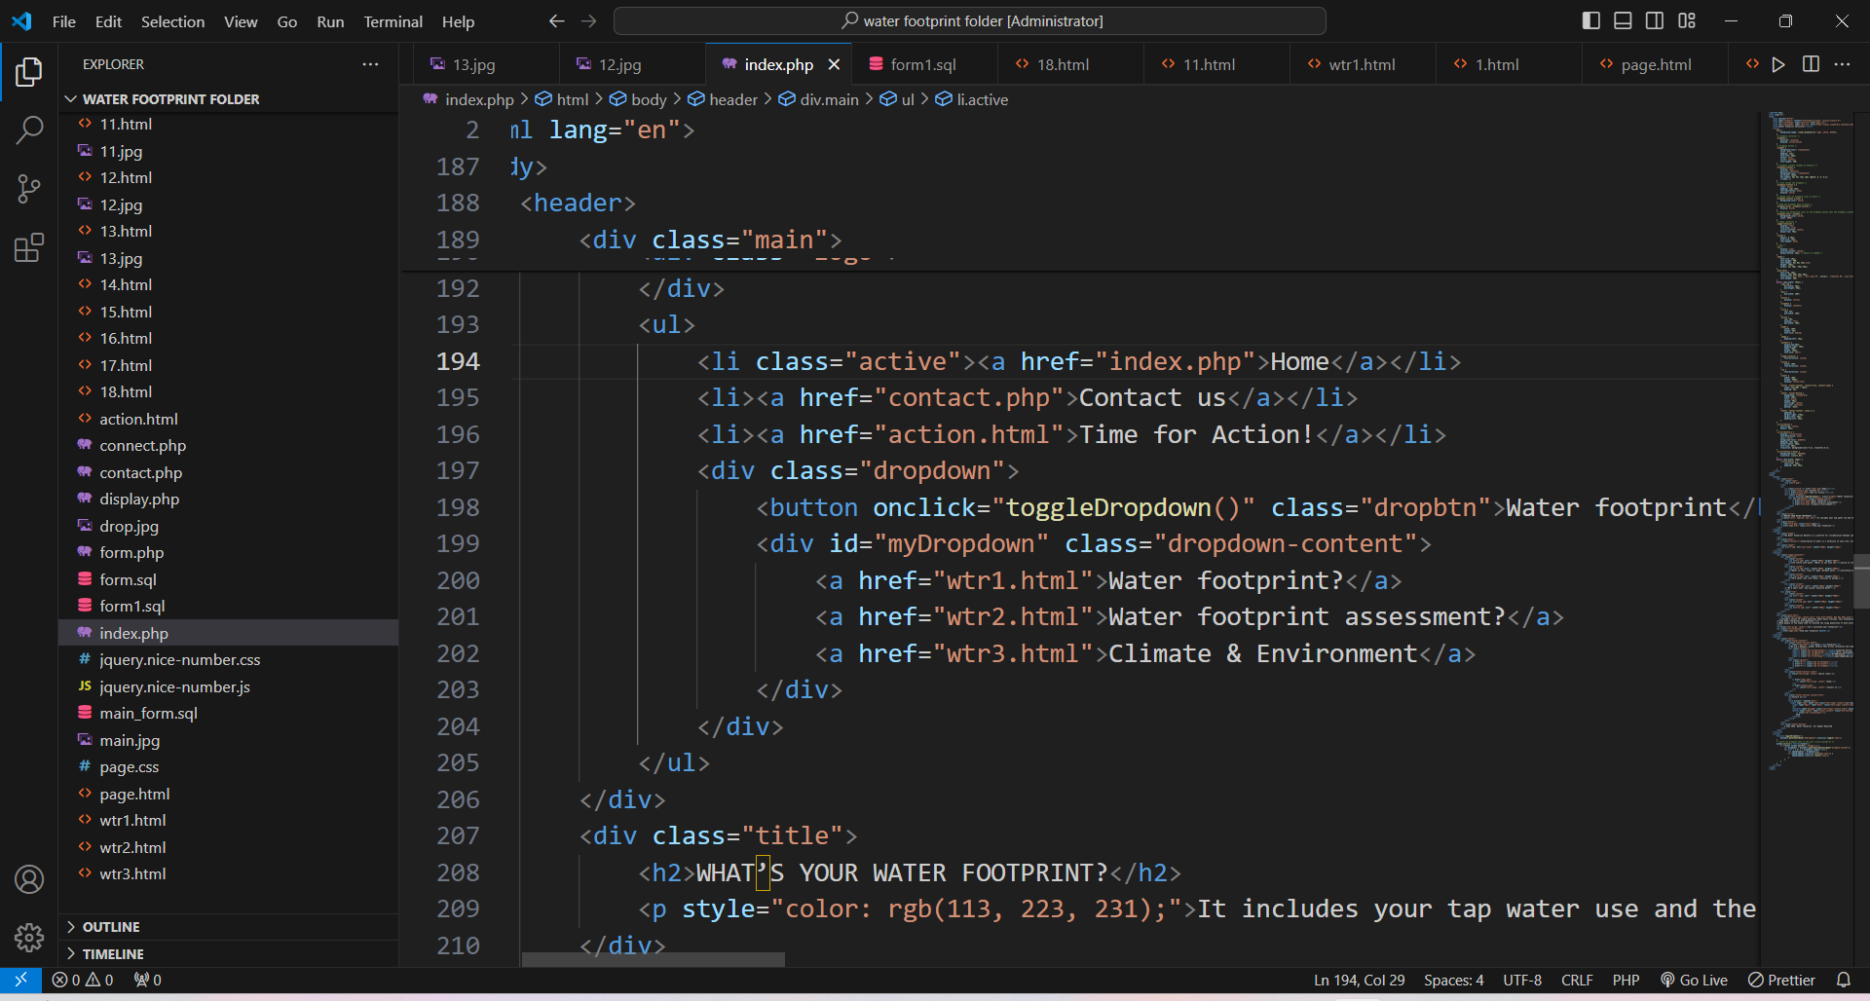

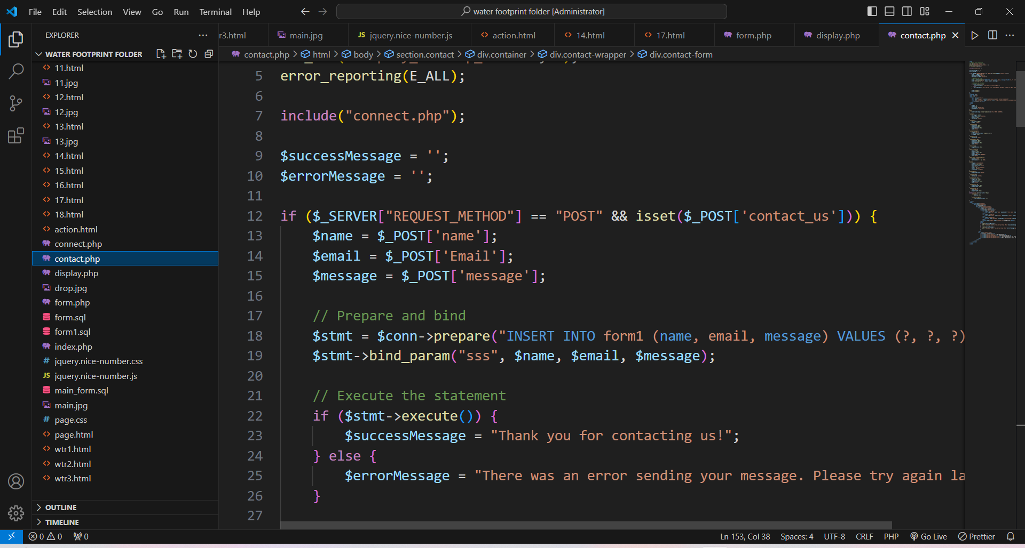 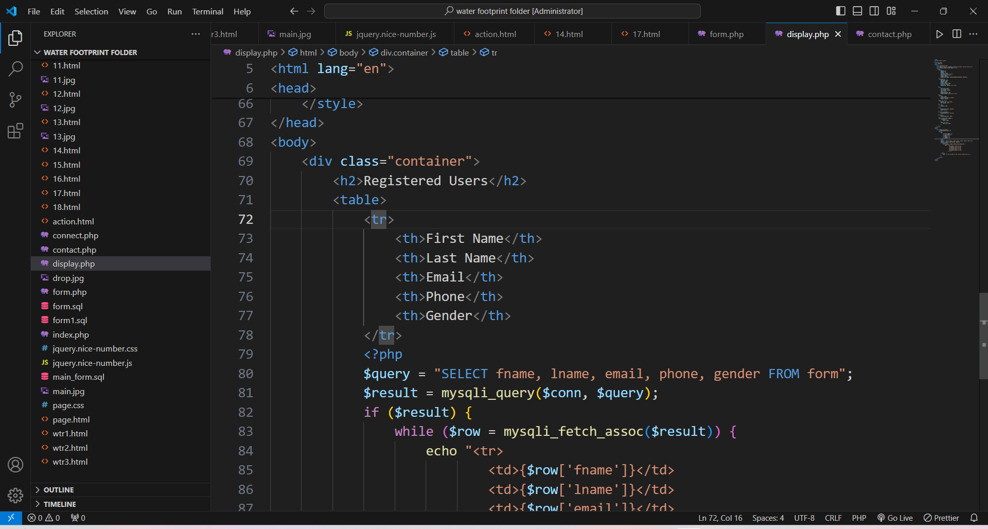

This a coding of the home page of the website…………

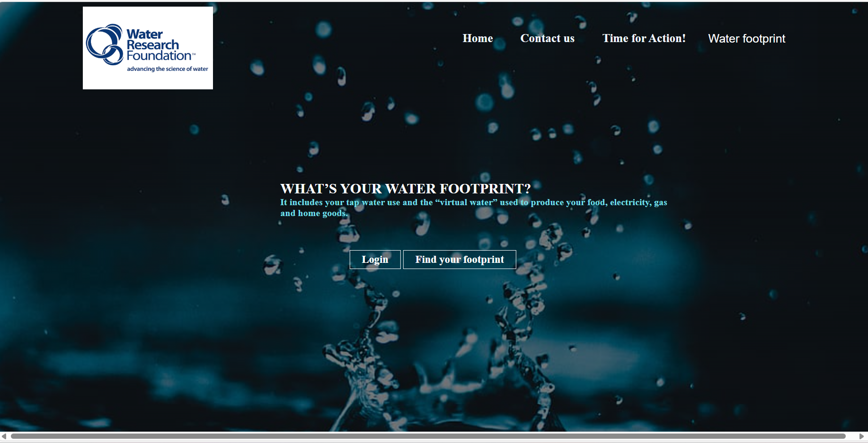

This is a home page (main page ) of the website where user can **login** the page by clicking login ,when user click to **find your footprint button** user can get to know about how much water is consumed depends on water usage, there is a information about **Time for action,** and **Waterfootprint** when user is clicking to this buttons.

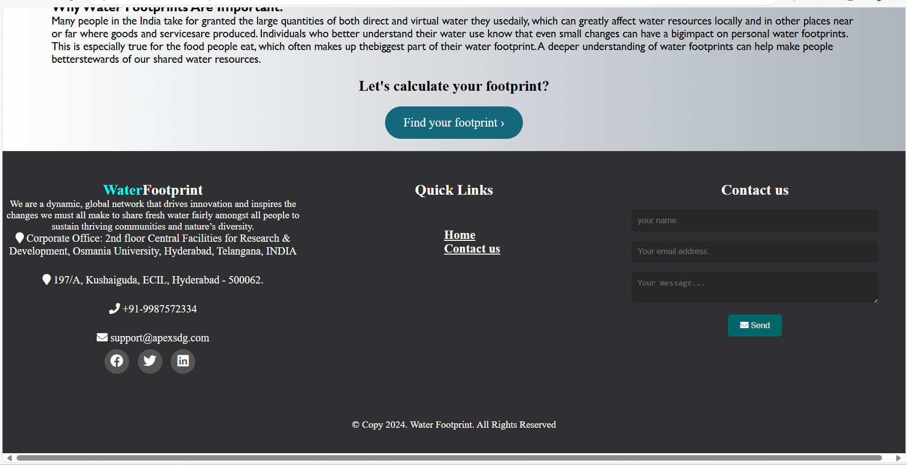 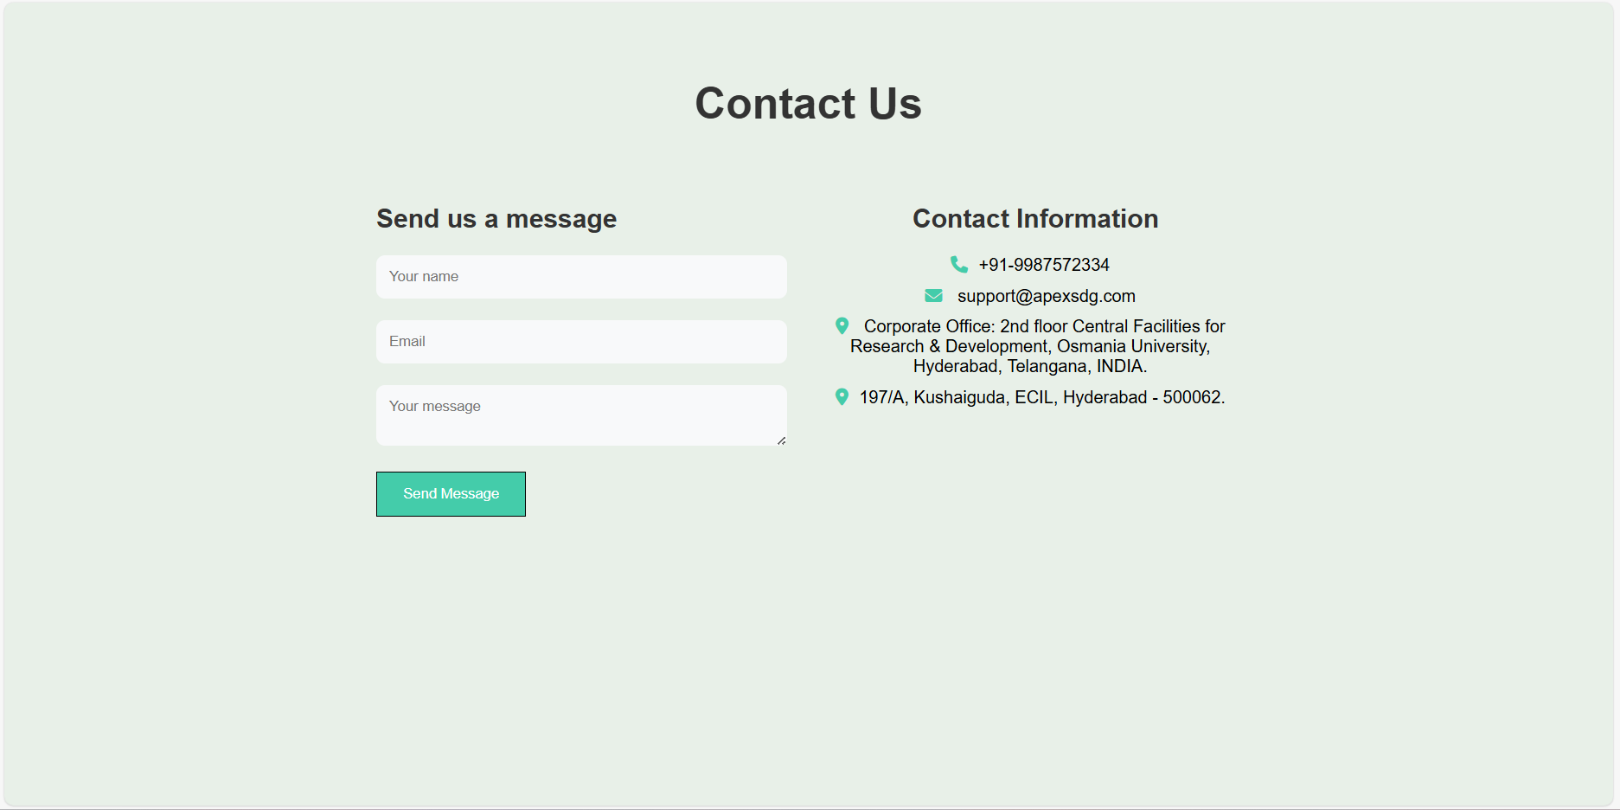

This is a footer of the website This is a contact page where

User can send message.

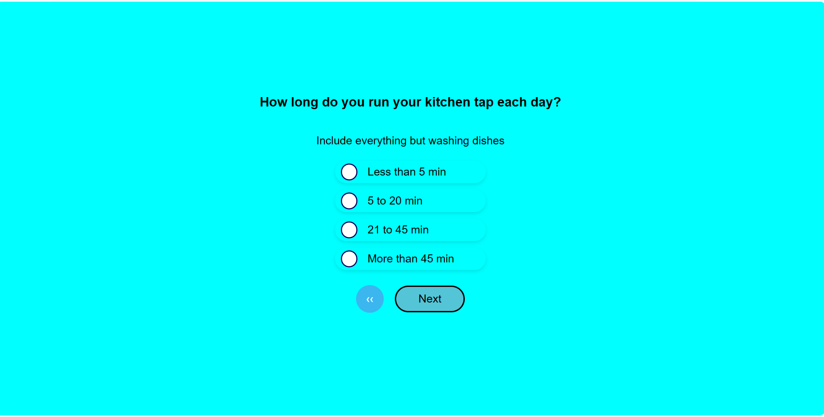

This a webpage of calculating the water consumption……

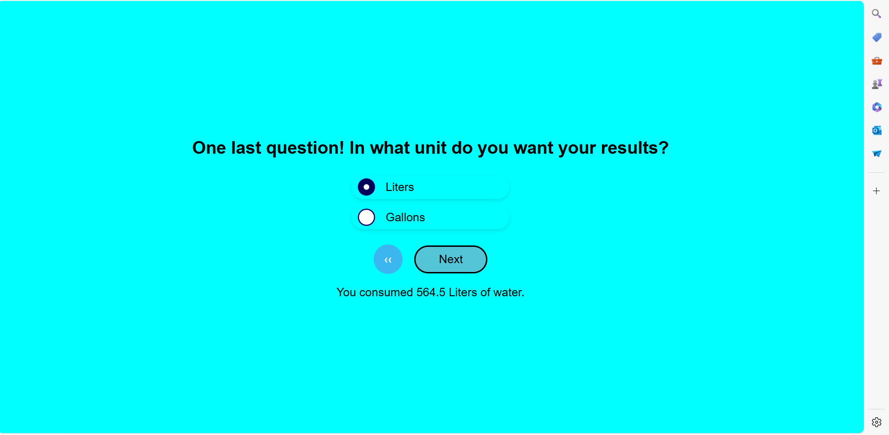

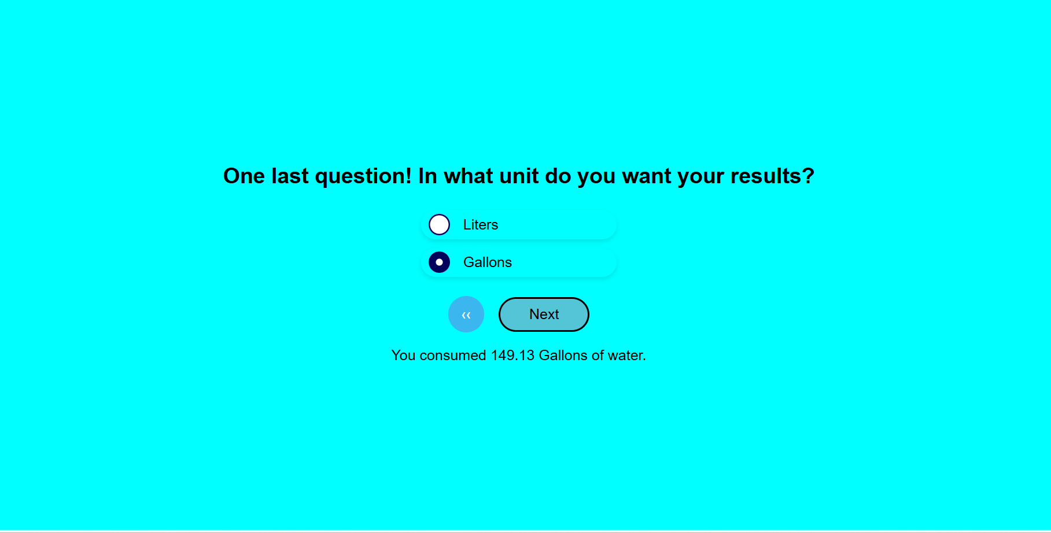

Through this a user’s can see their results in terms of Liters or Gallons.

**Features of the Project**

**Responsive Design**

Description: The Water Footprint Calculator is designed using responsive web design principles, ensuring optimal viewing and interaction experience across a wide range of devices, including desktops, tablets, and smartphones.

Significance: This approach enhances accessibility and usability, allowing users to access the calculator conveniently from any device without compromising on functionality or user experience. It accommodates different screen sizes and resolutions, adapting dynamically to provide an intuitive interface for users on various platforms.

**Interactive User Interface**

Description: The project features an engaging and user-friendly interface that guides users through the process of calculating their water footprint.

Key Elements:

Visual Design: Utilizes modern design elements such as intuitive navigation, clear information hierarchy, and visually appealing graphics to simplify complex data.

User Engagement: Incorporates interactive elements like sliders, dropdown menus, and progress indicators to enhance user engagement and ease of use.

Significance: By making the assessment process interactive and visually appealing, the interface encourages user participation and facilitates a better understanding of personal water consumption habits and their environmental impact.

**Comprehensive Assessment:**

Description: The calculator assesses both direct and indirect water usage, providing a holistic view of an individual's water footprint.

Key Features:

Direct Water Consumption: Calculates water usage from activities like drinking, bathing, and household chores.

Virtual Water: Estimates the water embedded in the production and consumption of goods and services, including food, energy, and manufactured products.

Significance: Offers users insights into the total water footprint associated with their daily activities, promoting awareness of hidden water consumption in everyday choices beyond direct usage. This comprehensive assessment empowers users to make informed decisions to reduce their overall water footprint.

**Educational Component**

Description: Alongside calculation functionalities, the project includes educational resources and tips on water conservation practices.

Key Components:

Informational Content: Provides educational content about the importance of water conservation, global water challenges, and the impact of individual actions on water resources.

Practical Tips: Offers practical suggestions and strategies for reducing water consumption and minimizing environmental impact.

Significance: Enhances user awareness and knowledge about sustainable water management practices. By educating users and providing actionable insights, the project aims to inspire behavioural changes that contribute to water conservation efforts on a personal and community level.

**Community Impact**

Description: The project aims to create a positive impact on communities by fostering awareness and promoting sustainable water use practices.

Community Engagement: Facilitates discussions and initiatives within communities to collectively address water conservation challenges.

Significance: By engaging individuals and communities in sustainable practices, the project contributes to broader environmental goals and supports efforts to safeguard water resources for future generation.

Technical Implementation

Description: The project leverages a robust technological stack to ensure functionality, scalability, and reliability.

Technological Components:

Front-End Technologies: Utilizes HTML5, CSS3, and JavaScript to create a responsive and interactive user interface.

Back-End Technologies: Implements PHP for server-side scripting and MySQL for data storage and management.

Significance: The technical implementation supports efficient data processing, seamless user interactions, and secure data management. It enables the Water Footprint Calculator to deliver accurate results and a smooth user experience, ensuring the reliability and scalability of the application.

**Innovation and Differentiation**

Description: Highlights unique aspects or innovative features that distinguish the Water Footprint Calculator from existing solutions.

Examples:

Integration of Virtual Water Calculation: Provides a comprehensive assessment by incorporating virtual water calculations, distinguishing it from simpler calculators that focus solely on direct water consumption.

Educational Emphasis: Emphasizes user education and awareness-building alongside calculation functionalities, aiming to empower users with knowledge for sustainable behaviour change.

Significance: Demonstrates the project’s innovative approach and its potential impact in promoting sustainable water management practices. It underscores the project’s contribution to environmental stewardship and community engagement through technological innovation.

**Current Development of the Project**

* **Core Functionality Established**: The main features of the "Water Footprint Calculator" have been successfully developed. Users can input their daily activities and receive accurate calculations of their water footprint, covering both direct and virtual water usage.
* **Interactive User Interface**: A user-friendly interface has been designed, making it easy for users to navigate through the calculator and understand their water consumption patterns. This interface is visually appealing and provides a seamless user experience.
* **Initial Sharing and Feedback**: The tool has been shared with Dr. Sudheer Kumar for internal review. Initial feedback has highlighted the calculator’s potential in raising awareness about water usage and its impact on sustainability.
* **Educational Content Integration**: The calculator now includes educational content that provides users with tips on how to reduce their water footprint and explains the importance of water conservation in everyday life.

#### Ongoing Developments:

* **User Interface Enhancements**: Continuous improvements are being made to the UI based on feedback. This includes refining the design elements to ensure clarity and ease of use, making the tool more engaging and accessible.
* **Algorithm Optimization**: The water usage calculation algorithm is being refined to enhance accuracy and expand the range of activities and products it covers. This ensures users get a comprehensive view of their water footprint.
* **Backend Performance Upgrades**: Ongoing efforts are focused on optimizing backend processes for better performance and reliability. This includes improving database queries and server responses to handle user data efficiently.
* **Localization and Accessibility**: Development work is underway to localize the tool into multiple languages and to improve accessibility features, ensuring that a diverse audience can use the calculator effectively.

#### Challenges and Solutions

* **Data Sourcing and Integration**: Obtaining accurate and comprehensive data for water usage across various activities has been challenging. We are collaborating with experts and utilizing reliable databases to ensure the tool's data integrity.
* **Maintaining User Engagement**: Balancing detailed information with user-friendly design is essential to keep users engaged. We are implementing layered information display options, allowing users to choose between summary views and detailed breakdowns.
* **Performance and Scalability**: As the tool grows, maintaining fast and responsive performance is critical. We are employing scalable technologies and cloud-based solutions to support increasing user loads and ensure smooth operation.

#### User Feedback and Testing

* **Internal Testing and Feedback Loop**: The tool has undergone thorough internal testing, with feedback from Dr. Sudheer Kumar being instrumental in identifying areas for improvement. This iterative feedback loop is crucial for refining the calculator’s features and performance.
* **Focus Group Insights**: Planned focus group discussions with potential users within the organization will provide deeper insights into the user experience and desired functionalities, helping to tailor the tool to meet diverse user needs.
* **Iterative Enhancement Process**: Continuous testing and user feedback are driving iterative improvements. Each round of testing informs adjustments that enhance both functionality and user experience, ensuring the tool meets high usability standards.

#### **Future Plans:**

* **Community and Social Integration**: Features to enable users to share their results on social media and engage with a community platform are in development. This will promote broader awareness and foster a community of water-conscious individuals.
* **Educational Outreach Initiatives**: Collaborations with educational institutions are planned to integrate the tool into curriculums and workshops, promoting water conservation awareness among students and the broader public.
* **Public Beta Testing**: Preparations are underway for a broader beta release to gather feedback from a wider audience. This phase will be crucial for fine-tuning the tool before a full public launch.

### **Future Scope**

#### Expansion of Features

* **Mobile Application Development**:
  + **Description**: Developing a dedicated mobile application for the "Water Footprint Calculator" would increase accessibility and convenience for users.
  + **Impact**: A mobile app would allow users to easily track their water usage on-the-go, making it more practical for daily use and increasing engagement.
* **Integration with Smart Home Devices**:
  + **Description**: Integrating the calculator with smart home devices like water meters and appliances could provide automatic, real-time data on water usage.
  + **Impact**: This integration would offer users precise tracking and insights without manual input, enhancing the accuracy and usability of the tool.
* **Enhanced Customization Options**:
  + **Description**: Allowing users to customize their water usage profiles based on specific lifestyle choices or geographical locations can provide more tailored and relevant insights.
  + **Impact**: Personalized recommendations and insights would increase the tool’s relevance and effectiveness, encouraging more sustainable behaviour tailored to individual circumstances.

#### Advanced Analytics and Reporting

* **Detailed Usage Reports**:
  + **Description**: Implementing advanced analytics to generate detailed reports on water usage patterns over time.
  + **Impact**: Users would benefit from visualized data trends and personalized insights, helping them understand their water consumption better and identify areas for improvement.
* **Comparative Analysis**:
  + **Description**: Enabling users to compare their water footprint with community averages or sustainable benchmarks.
  + **Impact**: This feature would foster a sense of community and competition, motivating users to reduce their footprint to be more in line with or better than the averages.
* **Predictive Insights**:
  + **Description**: Incorporating machine learning algorithms to provide predictive insights and proactive recommendations based on historical usage data.
  + **Impact**: Users could receive alerts about potential high water usage periods and suggestions for conserving water, enhancing their ability to manage and reduce their water footprint effectively.

#### Educational and Community Engagement

* **Integration with Educational Platforms**:
  + **Description**: Partnering with schools, universities, and educational organizations to incorporate the tool into curriculums and sustainability workshops.
  + **Impact**: This integration would raise awareness among students and young adults, promoting sustainable water use from an early age.
* **Community Challenges and Gamification**:
  + **Description**: Introducing community challenges and gamification elements to encourage collective action and engagement.
  + **Impact**: Features like leader boards, badges, and rewards for water-saving milestones can make water conservation more interactive and engaging, fostering a community-driven approach to sustainability.
* **Social Media Integration**:
  + **Description**: Adding social media sharing capabilities to allow users to share their progress and tips on reducing water usage.
  + **Impact**: Social media integration can amplify the tool’s reach, inspire others to use it, and create a larger impact through shared stories and successes.

#### Technical Improvements and Optimization

* **Scalability Enhancements**:
  + **Description**: Optimizing the back-end infrastructure to support a larger user base and more complex data processing.
  + **Impact**: Ensuring the platform can handle increased usage and data without compromising performance is crucial for long-term growth and user satisfaction.
* **User Interface Upgrades**:
  + **Description**: Continuously improving the user interface based on feedback to make it more intuitive and engaging.
  + **Impact**: A user-friendly interface enhances the overall user experience, encouraging more frequent and meaningful interaction with the tool.
* **Localization and Multilingual Support**:
  + **Description**: Adding support for multiple languages and localizing content to cater to a global audience.
  + **Impact**: This expansion would make the tool accessible to a broader demographic, supporting global water conservation efforts and making it relevant to diverse cultural contexts.

#### Strategic Partnerships and Outreach

* **Collaboration with Environmental Organizations**:
  + **Description**: Partnering with environmental NGOs and sustainability initiatives to promote the tool and incorporate it into broader conservation campaigns.
  + **Impact**: These partnerships can extend the tool’s reach and effectiveness, aligning it with larger efforts to combat water scarcity and promote environmental stewardship.
* **Corporate Engagement and CSR Initiatives**:
  + **Description**: Engaging with corporations to include the calculator in their Corporate Social Responsibility (CSR) programs.
  + **Impact**: Companies can use the tool to educate employees and customers about water conservation, amplifying its impact and supporting corporate sustainability goals.

#### Research and Development

* **Continuous Improvement Based on User Feedback**:
  + **Description**: Regularly updating the tool based on user feedback and emerging research in water conservation.
  + **Impact**: Keeping the tool up-to-date with the latest best practices and user needs will ensure it remains effective and relevant.
* **Exploration of New Technologies**:
  + **Description**: Investigating emerging technologies like artificial intelligence, blockchain for data security, and Internet of Things (IoT) for further enhancements.
  + **Impact**: Adopting cutting-edge technologies can open new avenues for improving the tool’s functionality and user experience.

**Conclusion**

#### Summary of the Project

* **Project Overview**:

"The 'Water Footprint Calculator' project aimed to create a comprehensive tool that allows users to measure their water usage and understand the broader implications of their daily habits on water resources."

* **Key Features and Achievements**:

"Throughout the development process, we successfully implemented key features such as an interactive user interface, detailed water consumption calculations, and educational components. The project has reached a stage where it provides valuable insights into both direct and virtual water usage….."

#### Learning Experience and Skills Gained

* **Technical Skills**:

"Working on this project has significantly enhanced my technical skills in web development. I have deepened my knowledge of HTML, CSS, JavaScript, PHP, and MySQL, learning how to integrate these technologies to build a functional and responsive web application.

* **Problem-Solving and Adaptability**:

"I encountered and overcame various challenges, such as optimizing the algorithm for accurate water usage calculations and ensuring the tool's responsiveness across different devices. These experiences have improved my problem-solving abilities and adaptability to complex tasks."

* **Collaboration and Professional Growth**:

"Collaborating with Dr. P. Sudheer Kumar(CEO,M/s APEX SDG-incubated at OTBI) and receiving feedback was invaluable. It taught me the importance of incorporating user feedback into the development process and helped me grow professionally by working in a team-oriented environment."

#### Broader Impact and Future Potential

"The 'Water Footprint Calculator' has the potential to significantly raise awareness about water conservation. By providing users with clear insights into their water consumption, the tool encourages more sustainable behaviours, contributing to the broader goal of environmental stewardship."

**Future Directions and Sustainability Impact of the Water Footprint Calculator :**

"Moving forward, the project has great potential for expansion. Future developments could include a mobile application, advanced analytics for tracking water usage trends, and integration with community engagement platforms. These enhancements would broaden the tool's reach and impact."

#### Personal Reflections and Gratitude:

"This internship has been a pivotal experience in my academic and professional journey. It has solidified my interest in combining technology with sustainability efforts, and I am excited to continue exploring this intersection in my future career."

"I am immensely grateful to Dr. P. Sudheer Kumar (CEO,M/s APEX SDG-incubated at OTBI)for his guidance and support, and to the entire OTBI team for providing a stimulating and supportive environment. Their mentorship has been instrumental in my learning and development."

#### 